

**​Feature extraction:** CNNs are particularly well-suited for computer vision tasks because they can automatically learn and extract meaningful features from images and videos, while traditional machine learning algorithms like MPLs require manual feature engineering.​ ​

**Handling large datasets:** CNNs can handle large datasets and can be trained on a large set of image data, while MPLs are not that efficient in handling large datasets.​ ​

**Handling image variations:** CNNs can handle variations such as different lighting conditions, angles, and rotations, while MPLs can struggle with these variations.​ ​

​ ​ ​ ​ ​ ​ ​

Why use CNN over MLP?

​

A kernel in a CNN is a small matrix used for performing a convolution operation which involves element-wise multiplication followed by addition and activation (such as ReLU) in order to extract both low-level features in the starting layers and high-level features in the top layers for feature extraction and transformation in convolutional layers.​

​ ​ ​ ​ ​ ​ ​ ​ ​ ​ ​ ​ ​ ​ ​ ​ ​ ​ ​ ​ ​ ​ ​ ​ ​ ​ ​ ​ ​ ​ ​ ​ ​ ​ ​ ​ ​ ​

​ What is a Convolutional and Convolution operations​?



In a Convolutional Neural Network (CNN), features can be classified into different levels based on their complexity and abstraction, such as low-level features (e.g. edges, textures), mid-level features (e.g. parts of objects), and high-level features. (e.g. whole objects, scenes). ​

​ ​ ​ ​ ​ ​ ​ ​ ​ ​ ​ ​ ​ ​ ​

​ CNN Feature levels

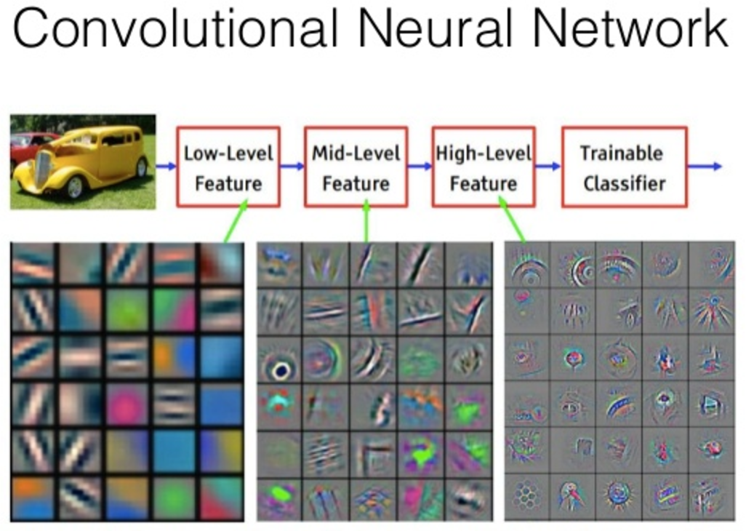

Pooling layers provide an approach to down-sampling feature maps by summarizing the presence of features in patches of the feature map. This has the effect of making the resulting down-sampled feature maps more robust to changes in the position of the feature in the image, referred to by the technical phrase “local translation invariance.”

Max- Pooling - Each pooling operation selects the maximum value of the current view.

Average-pooling - Each pooling operation averages the values of the current view​

​ ​ ​ ​ ​ ​ ​

What is Pooling?



Valid and same padding in CNNs are methods of handling the spatial dimensions of input and output matrices during the convolution operation, with "valid" reducing the output size and "same" preserving the input size in the output.​

Fig 1 shows ‘Valid’ and other 3 shows ‘Same‘​ Padding ​ ​ ​ ​ ​ ​ ​ ​ ​

​

​ ​ ​ ​ ​ ​ ​

What is Padding?



For Convolution layer with k filters of size f x f and the input channel of image c:

Total Parameter = k x (f x f x c_in) + k​ ​

For a Fully Connected layer with n neurons and number of input I:​

Total Paramenter = n x ( I + 1)​ ​

By calculating the number of parameters in each layer and summing them up, you can obtain the total number of parameters in the entire CNN.​ ​

​ ​ ​ ​ ​ ​

​ Number of parameter​ ​

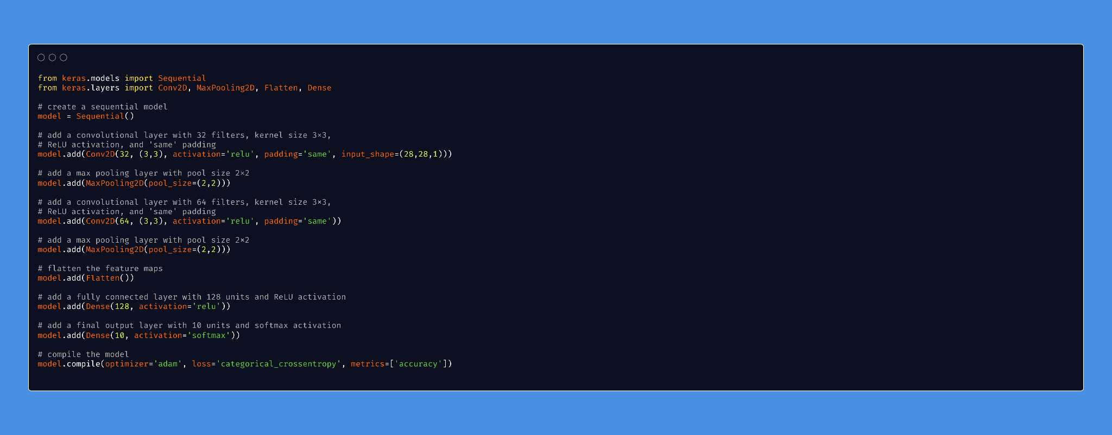

Final Code

The shape of the output in a Convolutional Neural Network (CNN) is determined by the size of the input, the size of the filters used in the convolutional layers, the stride of the convolutional operations, and the padding applied to the input.

The formula for the shape of the output layer in a CNN is determined by the input shape, the kernel size, the stride and the padding.​

​ ​ ​ ​ ​ ​

​ Shape of output layer

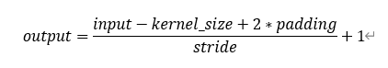

In Convolutional Neural Networks (CNNs), strides are the number of pixels the convolution filter moves when scanning over the input, determining the size of the output feature map.​ ​ ​

​ ​ ​ ​ ​ ​

​ What is a Strides ?​

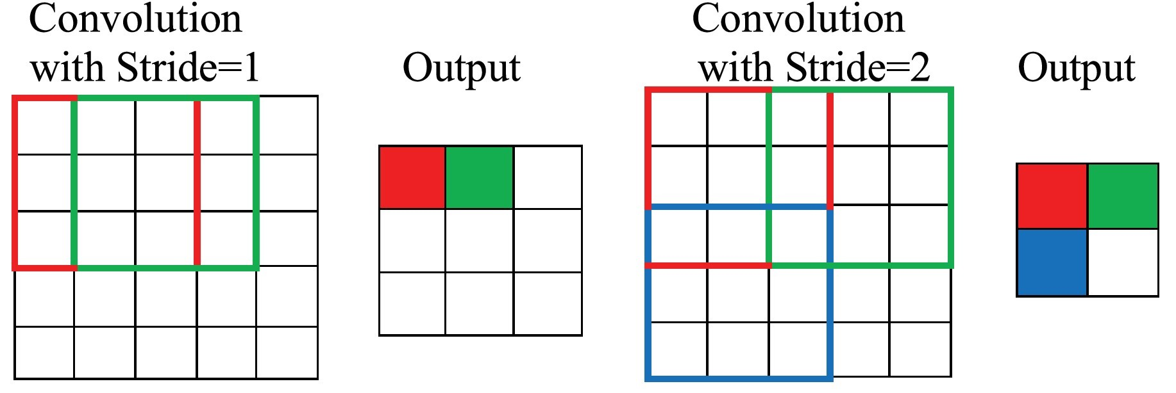

L2: Revisiting CNN Deal with Overfitting Cheat Sheet

Overfitting occurs when a model is too complex and learns irrelevant details from the training data, causing poor performance on new data.

What is Overfitting?

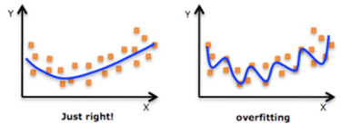

Global Average Pooling 2D is a type of pooling operation used in Convolutional Neural Networks (CNNs).

It takes the average of all feature maps in a given input and outputs a single value for each feature map, reducing the spatial dimensions of the feature maps.

This operation is useful for capturing the global spatial information of an input while reducing the computational cost and overfitting.

Global Average Pooling

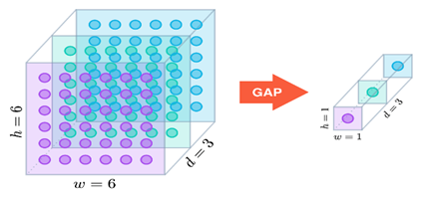

Dropout is a regularization technique used in deep learning to prevent overfitting by randomly dropping out (i.e. setting to zero) a specified portion of neurons during each training iteration.

This helps to prevent the network from relying too heavily on any single feature and encourages it to learn multiple redundant representations of the data.

Dropout

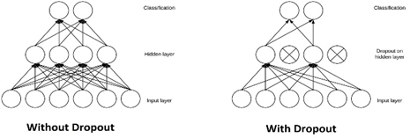

**Regularization**: Use techniques like L1, L2 regularization or Dropout to reduce the complexity of the model and prevent overfitting.

**Early Stopping**: Monitor the model's performance on a validation set and stop training when the performance starts to deteriorate.

**Data augmentation**: Increase the size of the training set by applying random transformations to the input images, such as rotation, scaling, and flipping.

**Transfer Learning**: Use pre-trained models as a starting point and fine-tune the model on your own data.

**Model Ensemble**: Combine the predictions of multiple models to obtain a more robust result and reduce overfitting.

**Reducing network complexity**: Reduce the number of parameters in the network by using smaller filter sizes, fewer filters, or smaller dense layers.

Methods to Avoid Overfitting

Emperically it has been found out that dropout works best when it is placed in-between Dense layers of an architecture with a probability of 0.5.

Sometimes adding dropout layers after MaxPooling Layer with lower probability (0.1 to 0.25) also enhances performance.

If we normalize the feature distribution right after Conv Layer and pass it to the ReLU block, it will clamp the negative values from BN output to 0, effectively changing the distribution itself and defeating the purpose of normalization.

When to use Batch Normalization and Dropout

Batch normalization is a technique used in deep learning to improve the stability and speed of training by normalizing the activations of neurons across each batch in a mini-batch training process.

It involves transforming the activations of each batch of data to have a mean of zero and a standard deviation of one before passing them through the next layer of the network.

Batch Normalization

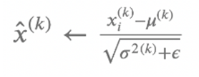

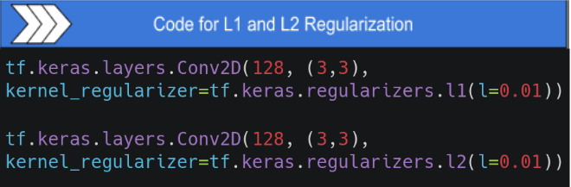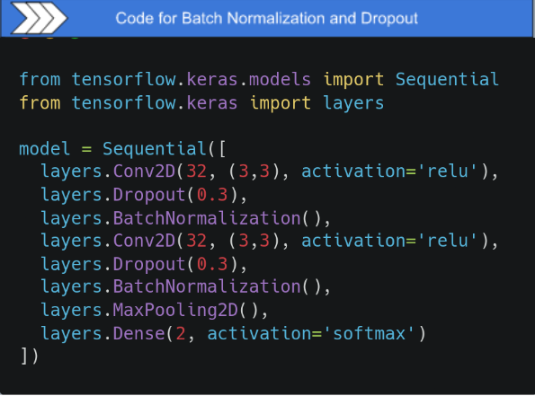

There are many ways to apply augmentation in Tensorflow/Keras, few of them are discussed here:

using the **Keras** Preprocessing Layers, just like preprocessing functions like resizing and rescaling, keras also provides data augmentation layers like **tf.keras.layers.RandomFlip**, **tf.keras.layers.RandomRotation**, etc. These can be used in a similar way as we used the preprocessing functions.

using tf.image methods like **tf.image.stateless_random_flip_up_down**, **tf.image.stateless_random_brightness**

using Keras **ImageDataGenerator** API - It provides quick, out-of-the-box suite of augmentation techniques like standardization, rotation, shifts, flips, brightness change, and many more.

Ways to Apply Data Augmentation

**L1 Regularization:**

Also known as Lasso regularization, L1 regularization adds a penalty term to the loss function proportional to the absolute magnitude of the weights.

L1 regularization is often used in cases where we have a high number of features and want to reduce the number of features the model uses.

**L2 Regularization:**

Also known as Ridge regularization, L2 regularization adds a penalty term to the loss function proportional to the square of the magnitude of the weights.

L2 regularization is often used as a default regularization technique in deep learning as it helps to prevent overfitting without inducing sparsity in the solutions.

L1 Regularization VS L2 Regularization

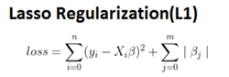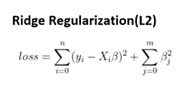

Examples of Data Augmentation

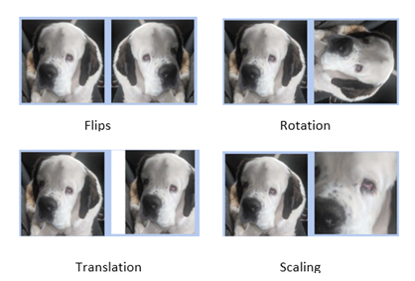

Data augmentation is a technique used in Convolutional Neural Networks (CNNs) to artificially increase the size of the training data by applying various transformations to the input images.

The purpose of data augmentation is to prevent overfitting, which occurs when the model is too complex and learns the training data too well, causing poor generalization to new, unseen data.

Examples of data augmentation techniques used in CNNs include:

**Rotation**: Rotating the images by a random angle.

**Scaling**: Resizing the images to a different scale.

**Translation**: Shifting the images horizontally or vertically by a random amount.

**Flipping**: Flipping the images horizontally or vertically.

Data Augmentation

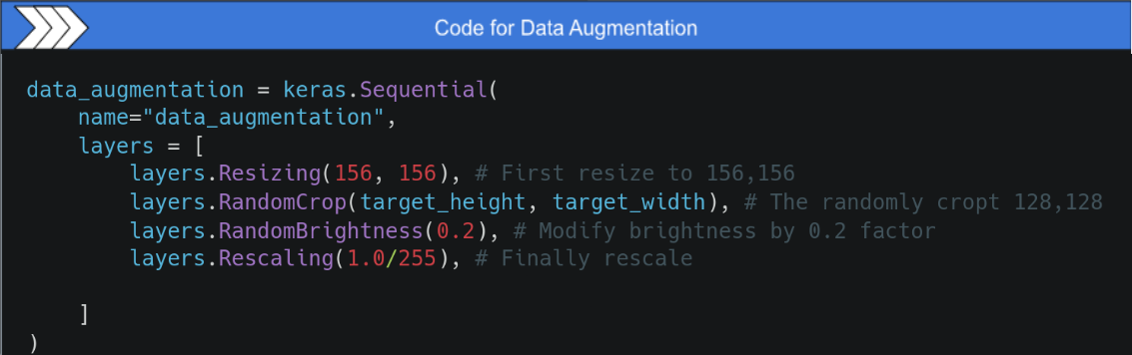



L3: CNN Under The Hood Cheat Sheet

Backward Propagation refers to updating the weights and biases of our model with respect to the loss of our model.

The derivative of error with respect to :

Kernel

Bias

Input is calculated during backpropagation

Backward Propagation in CNN

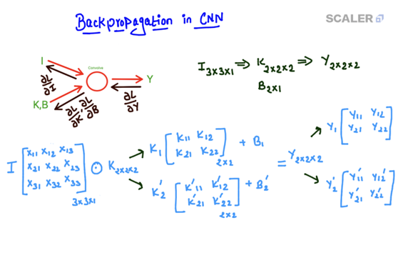

The forward function iterates through every filter in every image channel and

it pass over a kernel of specified size over the image and

perform the convolution operation between the kernels and the input image.

Forward propagation mathematically for the Convolutional Layer is as follows:

Forward Propagation in CNN

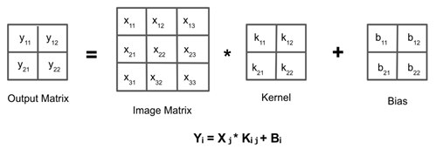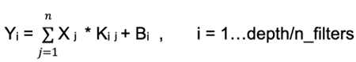

Code for Forward Propagation in Filters

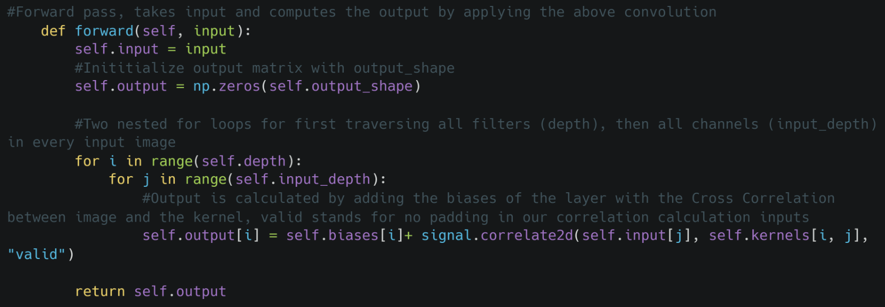

Loss Gradients

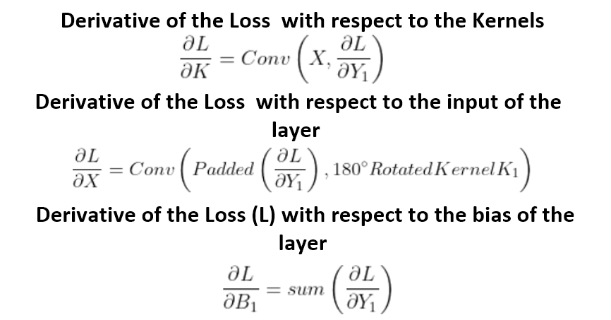

Code for Backward Propagation in Filters

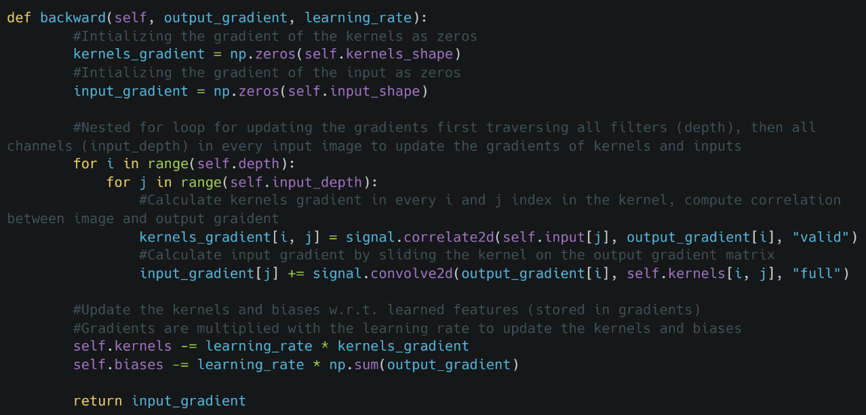

Forward Propagation : Select the max value inside the kernel window

Max Pooling for Forward Propagation

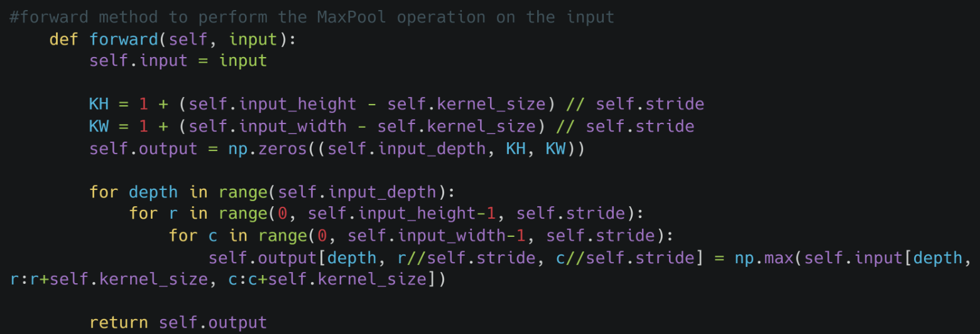

Backward Propagation : Select only the elements in our input matrix that were selected during the forward propagation of the Maxpool layer, zeroing out all the other indices that were not selected during forward propagation

Max Pooling for Backward Propagation

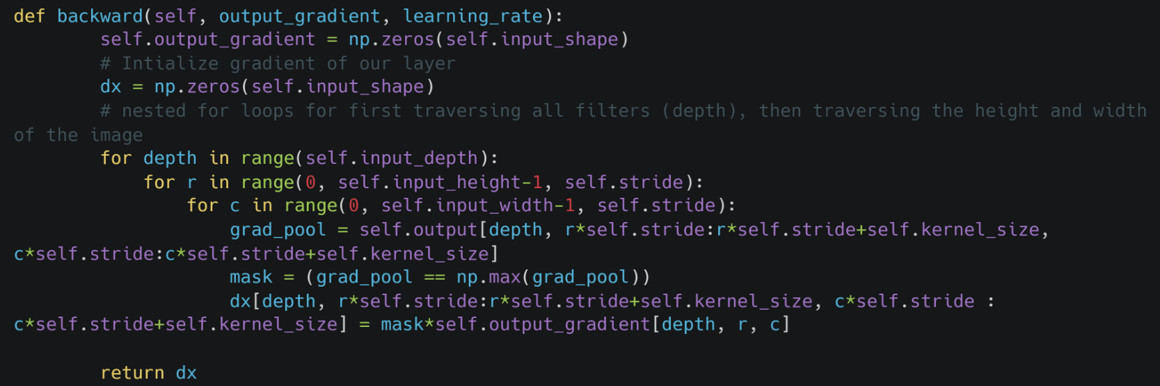





Tanh Activation Function

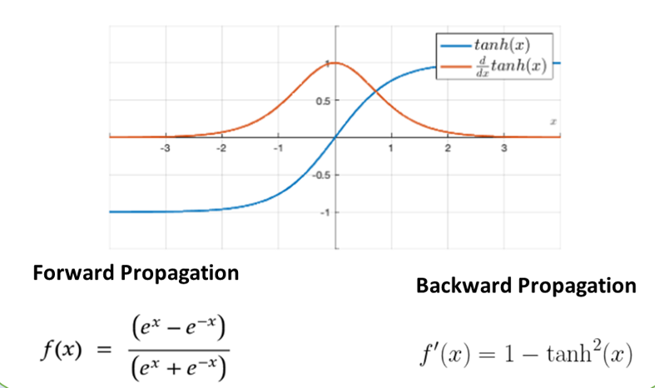

Log Loss Function

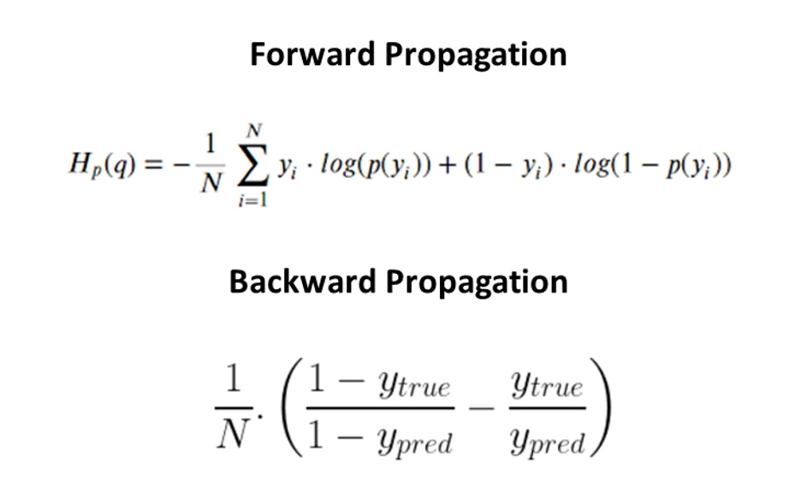

L4 : Introduction to ​Transfer Learning​ Cheat Sheet

ImageNet Competition: The ImageNet Large Scale Visual Recognition Challenge (ILSVRC) is an annual computer vision competition held to evaluate the performance of computer vision models on a large scale image classification task.​ ​

Significance: The ImageNet competition has been instrumental in advancing the state-of-the-art in computer vision, with deep learning models winning the competition since 2012. ​ **​ ​ ​**

​ ​ ​ ​ ​ ​ ​

​ What is ImageNet competition?​

Top-k accuracy refers to the accuracy of a model's top k predictions compared to the actual target classes.​

For example, if we have a multi-class classification problem with 5 classes and a model makes the following predictions:​

Prediction: [0.1, 0.3, 0.5, 0.8, 0.2] | True class: 3​ If we set k=3, the model's top 3 predictions are classes 2, 3, and 4.

Since class 3 is the true class, the top-k accuracy would be 1.0, indicating a correct prediction.​ ​ **​ ​ ​**

​ ​ ​ ​ ​ ​ ​

​What is Top-k accuracy?

Graphics processing units (GPUs)​

Rectified linear unit (ReLU) activation​

Regularization (Dropout and Data Augmentation)​

Pooling layers​

Increasing the Depth​

​ ​ ​ ​ ​ ​ ​

​ What was so new about AlexNet?​ ​

VGGNet Architecture

VGG19 won second place in 2014​ It was designed by the Visual Geometry Group (VGG) at the University of Oxford, UK.​

VGG16 has top 5 acc of 91.9 and top 1 acc of 74.4 on ImageNet dataset.​ ​

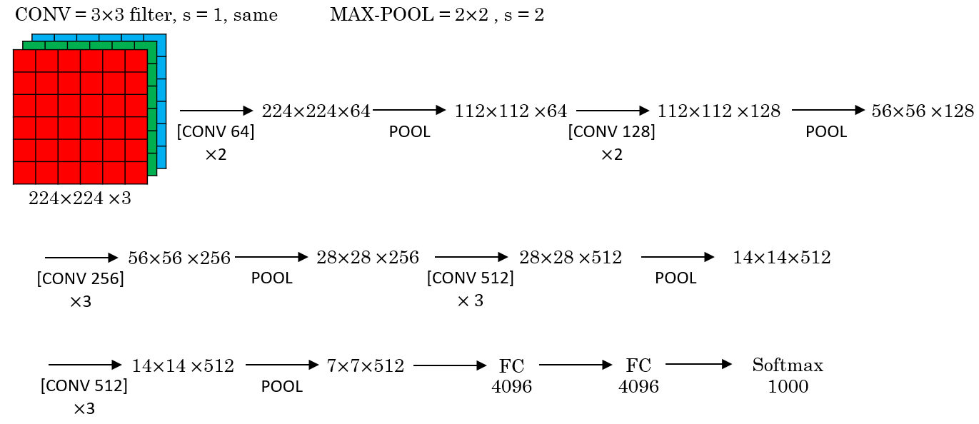

**Definition**: Transfer learning is a machine learning technique in which a pre-trained model is used as a starting point to solve a similar but different problem.​ ​

**Advantages:** ​

1. Transfer learning is often used in computer vision because it allows one to leverage the knowledge learned from large amounts of data in one task to another, similar task.​

2. This can result in improved performance and faster training times, as well as reduced data and computational requirements compared to training a CNN from scratch. ​

3.Additionally, transfer learning can be useful when there is limited annotated data available for a particular problem.​ ​ ​ ​ ​ **​ ​ ​**

​ ​ ​ ​ ​ ​ ​

​ What is Transfer Learning ?​ ​

4. Difficulty in Training: VGG-16's deep architecture and large number of parameters can make training challenging and time-consuming, especially when using limited amounts of annotated data.​

5. Lack of Spatial Information: VGG-16 uses max pooling to reduce the spatial resolution of the feature maps, which can result in the loss of spatial information and reduce the model's ability to capture fine-grained details in images.​

​

​ ​ ​ ​ ​ ​ ​

​ Some more shortcomings of VGG-16​ ​

AlexNet Architecture​

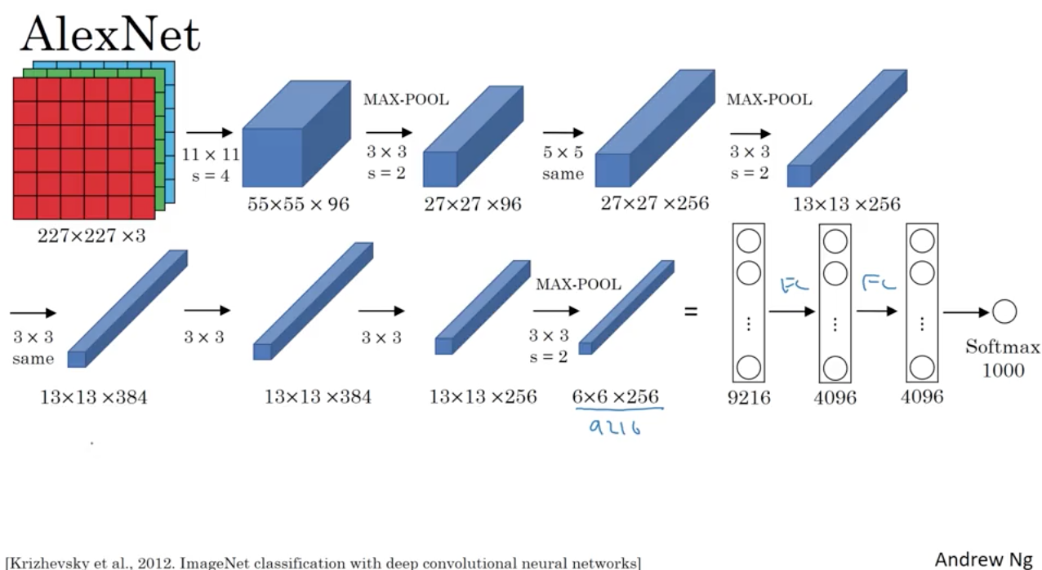

AlexNet is the first CNN to win ImageNet Competition in 2012.​

It was primarily designed by Alex Krizhevsky.​

They achieved a top 5 accuracy of 84.7%, while runner-up was at 74!​ ​

Deeper Network​

Smaller Filters​

Pooling Layers: VGG-16 employs more pooling layers​

Uniform Filter Size - VGG-16 uses the same filter size (3x3) throughout the network​

​ ​ ​ ​ ​ ​ ​

Improvements of VGG-16 over AlexNet ​





Complexity: VGG-16 has a large number of parameters, making it computationally expensive to train and difficult to deploy on low-power devices.​

Overfitting: Due to its large number of parameters, VGG-16 is prone to overfitting if not regularized properly, which can result in poor performance on unseen data.​

Large Memory Requirements: VGG-16 requires a large amount of memory to store its parameters, making it challenging to run on smaller devices with limited memory.​

​ ​ ​ ​ ​ ​ ​

​ What are the shortcomings of VGG-16​ ​



L5: Image Similarity Using CNN Cheat Sheet

Architecture of Image Similarity

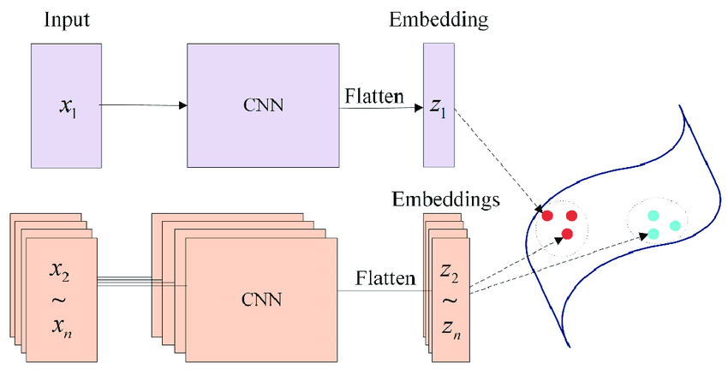

Image similarity is the measure of how similar two images are.

In other words, it quantifies the degree of similarity between intensity patterns in two images.

Finding Image similarity also called reverse image search

What is Image Similarity?

An image embedding is a lower-dimensional representation of the image.

In other words, it is a dense vector representation of the image which can be used for many tasks such as classification.

A convolutional neural network (CNN) can be used to create the image embedding.

What is an Embedding?

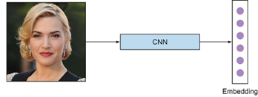

**VGG:**Large number of parameters: VGG has a large number of parameters, making it prone to overfitting and memory-intensive.

Computationally expensive: The use of small 3x3 filters results in a large number of operations and can be computationally expensive.

**AlexNet:**Limited representational capacity: AlexNet has a relatively shallow architecture with limited representational capacity, which can limit its ability to learn complex features and representations.

Over-reliance on data augmentation: AlexNet was heavily reliant on data augmentation techniques, such as image flipping and color shifting, which can be time-consuming and may not always be appropriate.

Drawbacks of VGG and AlexNet

Deeper architectures in Convolutional Neural Networks (CNNs) are needed to improve the performance of the network by allowing it to learn more complex representations of the data

.

A deeper network has more layers, and each layer can learn to extract a different and more abstract representation of the data.

This allows the network to learn increasingly complex features, such as shapes, textures, and patterns, that are important for image classification and other computer vision tasks.

Why do we need Deeper Architecture?

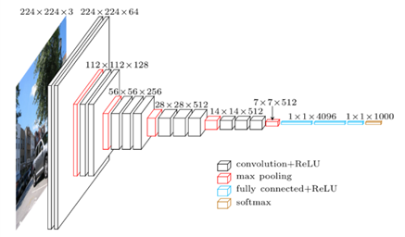

**ResNet:**

**Residual connections**: ResNet introduced the concept of residual connections, which allow the network to learn residual representations instead of direct representations.

This helps prevent vanishing gradients and enables the network to train deeper models without degradation in performance.

Improved representational capacity: ResNet has a much deeper architecture than VGG and AlexNet, which allows it to learn more complex representations.

**Inception:**

**Improved efficiency**: The Inception architecture uses multiple parallel branches with different filter sizes and concatenates the results, which allows the network to learn multiple scales of features efficiently.

Reduced number of parameters: Inception uses multiple smaller filters instead of a few large filters, which reduces the number of parameters and reduces the risk of overfitting.

How ResNet and Inception better than AlexNet and VGG?

Skip connections in Convolutional Neural Networks (CNNs) are connections that bypass one or more layers in the network, allowing the gradients to flow more easily through the network during training.

The idea behind skip connections is to mitigate the vanishing gradient problem, which can occur in very deep networks and cause the gradients to become very small, making training difficult.

Skip connections allow the activations from earlier layers to be combined with the activations from later layers, allowing the network to maintain a stronger gradient signal throughout the network.

This can help to improve the training process and allow the network to learn more complex features.

What are Skip connections?

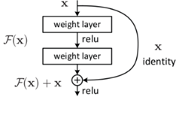

Vanishing Gradient

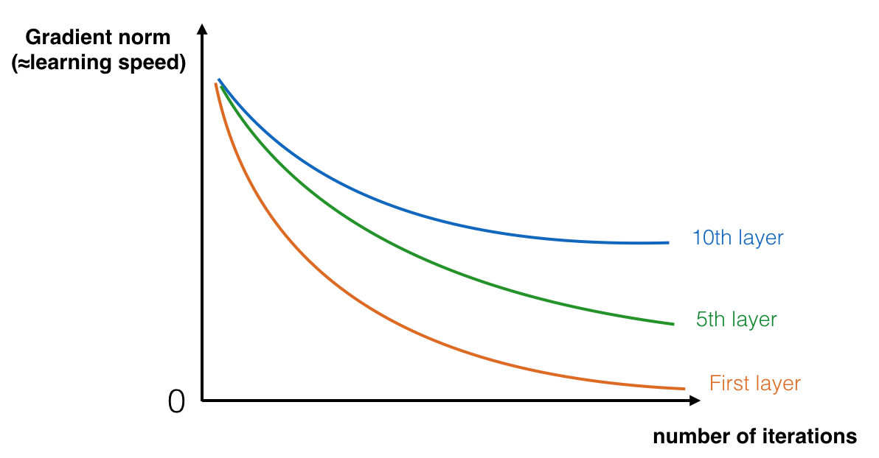

The speed of learning decreases very rapidly for the early layers as the network trains



Skip connections in Convolutional Neural Networks (CNNs) are connections that bypass one or more layers in the network, allowing the gradients to flow more easily through the network during training.

The idea behind skip connections is to mitigate the vanishing gradient problem, which can occur in very deep networks and cause the gradients to become very small, making training difficult.

Skip connections allow the activations from earlier layers to be combined with the activations from later layers, allowing the network to maintain a stronger gradient signal throughout the network.

This can help to improve the training process and allow the network to learn more complex features.

What are Skip connections?



We use multiple levels of Feature Extraction in CNN because At lower levels, the network extracts simple features such as edges and corners, which are combined to form higher-level features such as textures and shapes.

These higher-level features are then combined to form even higher-level representations such as object parts and eventually complete objects.

By using multiple levels of feature extraction, the network can learn to recognize objects and their relationships from a wide range of viewpoints and scales.

Why do we need Multi-level Feature Extractor?

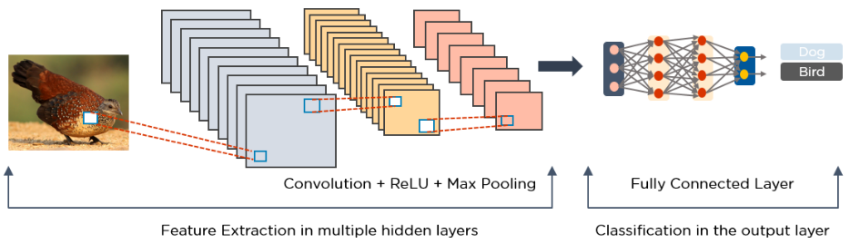

GoogleNet (Inception) Architecture

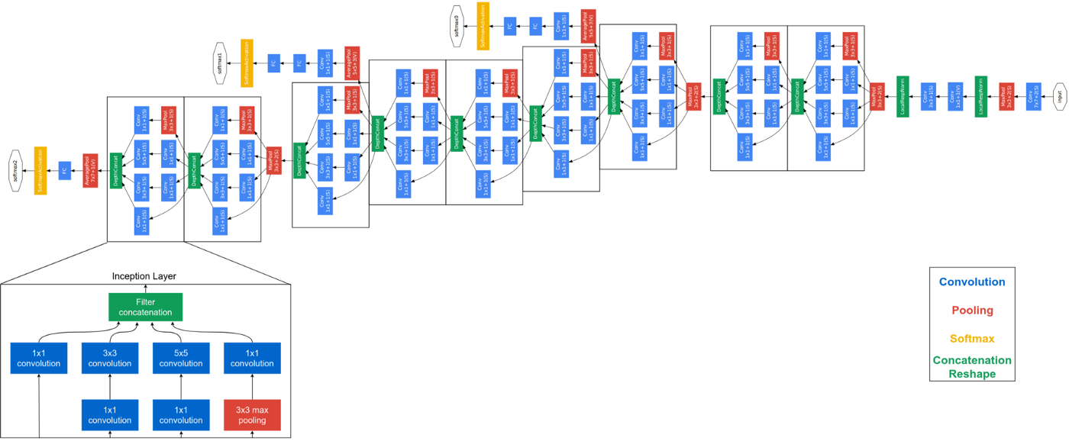

Architecture of Inception Module

